Mapping code

Overview : First, copy the mapping code provided to you, as it is needed to connect your Petpooja Billing system with the desktop application. Open the Owner Dashboard and go to the Desktop Application settings. There you will see the Quick Add option—click on it, and a pop-up window will open. In this window, paste the mapping code and click on the Map button to save it. After saving, go to the Billing POS section and click on Verify to check if the code is working correctly. If the verification is successful, your configuration is complete, and your system will now be properly connected and ready to use without any issues.

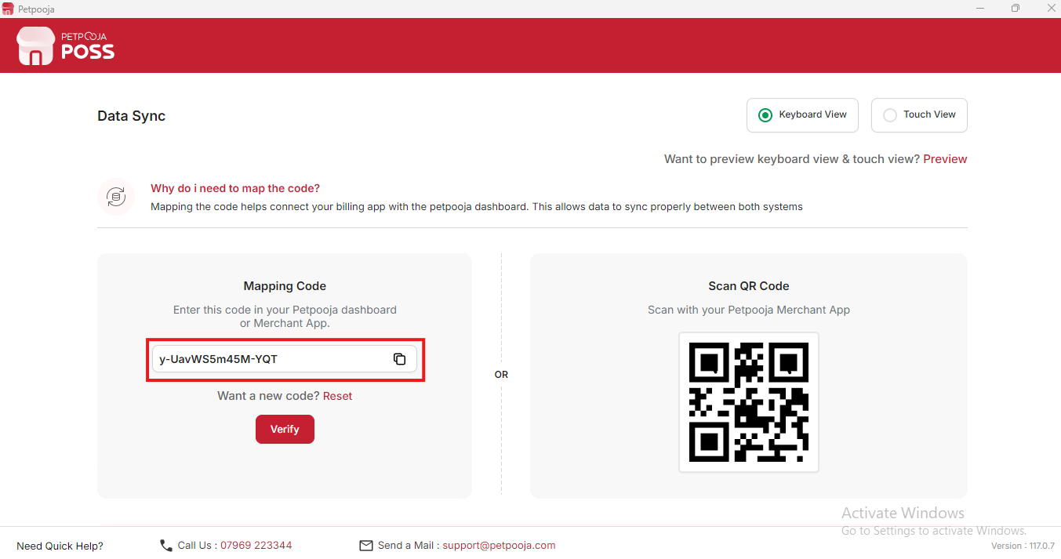

{Image Name: Data Sync - Mapping Code,

Description: This image highlights the "Mapping Code" section where the code is displayed for linking the billing app with the Petpooja dashboard, valid for syncing both systems.}

(Mapping code) Mapping Code Configuration (Step by Step)
- Copy the Mapping Code (Mapping Code Configuration) :
  - First, make sure you have the mapping code provided to you.
  - This code is important because it links your Petpooja Billing system with the desktop application.
- Open the Owner Dashboard (Mapping Code Configuration) :
  - Go to your browser and open this path: Billing.petpooja.com >> Setting >> Desktop Application
  - This will take you to the settings area where all desktop application configurations are managed.
- Use Quick Add Option (Mapping Code Configuration) :
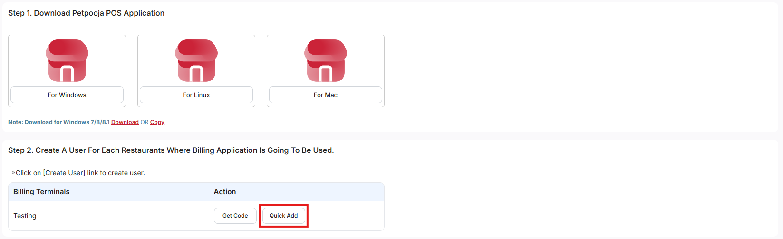
{Image Name: Quick Add Option in Billing Terminals,
Description: This image highlights the "Quick Add" button in the Billing Terminals section, used to quickly create a user for the billing application.}

  - On the Desktop Application page, you will see an option called Quick Add.
  - Click on Quick Add to open a pop-up window.
- Enter the Mapping Code (Mapping Code Configuration) :
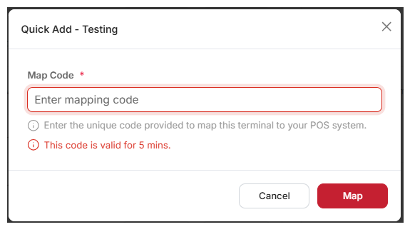
{Image Name: Quick Add - Mapping Code,
Description: This image shows the "Quick Add" pop-up where a mapping code must be entered to link the billing terminal, with the code valid for 5 minutes.}
  - In the pop-up window, you will find a field to enter the code.
  - Paste the mapping code that you copied earlier.
  - After pasting, click on the Map button to save the code.
- Verify in Billing POS (Mapping Code Configuration) :
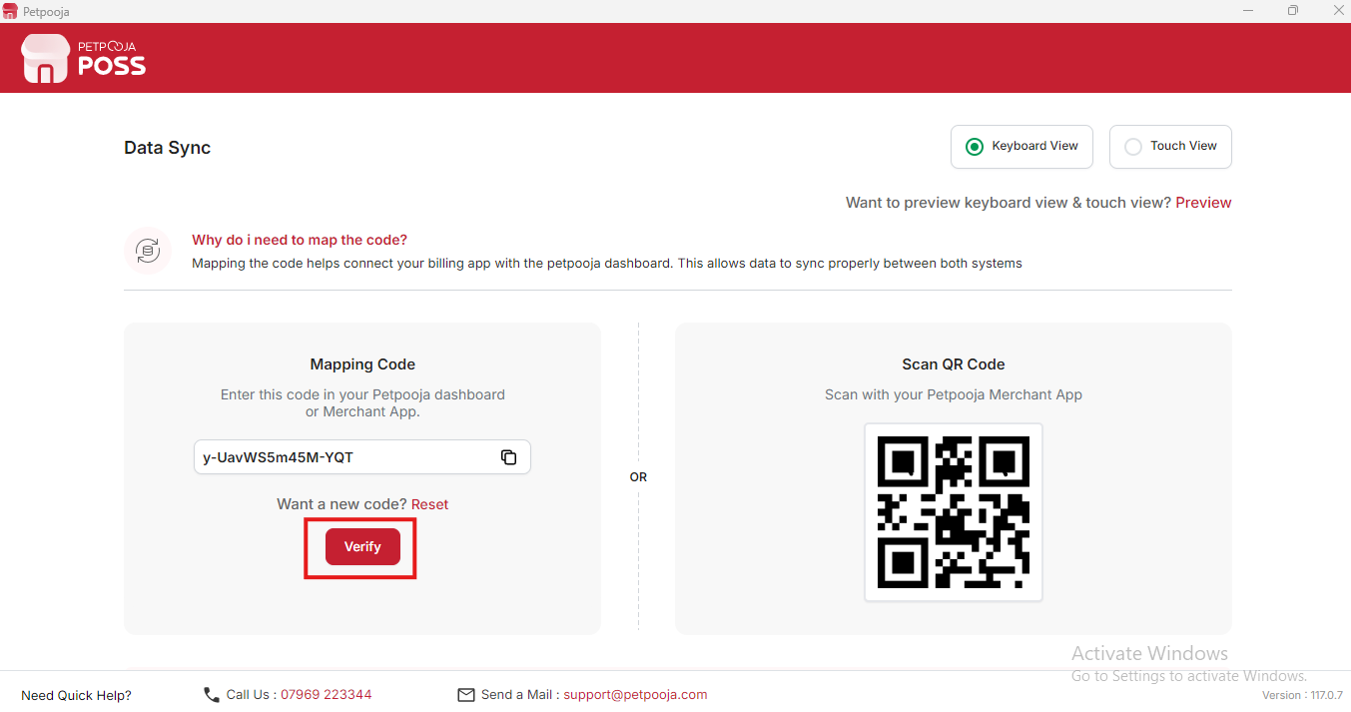
{Image Name: Data Sync - Verify Mapping Code,
Description: This image highlights the "Verify" button in the Mapping Code section, used to confirm and connect the billing app with the Petpooja dashboard.}
  - Once the code is mapped, go to the Billing POS section.
  - Inside Billing POS, you will see an option called Verify.
  - Click on Verify to confirm that the mapping is working correctly.
- Configuration Completed (Mapping Code Configuration) :
  - If the verification is successful, your configuration setup is complete.
  - Now your system is properly connected and ready to use without any issues.

